ATF implementation for Catalog

1. Create new Test Case with the following Test steps
   1. Add Steps one by one
   2. First add Open Catalog form
   3. Set the quantity to 10
   4. Add item to shopping cart
   5. Order Catalog item

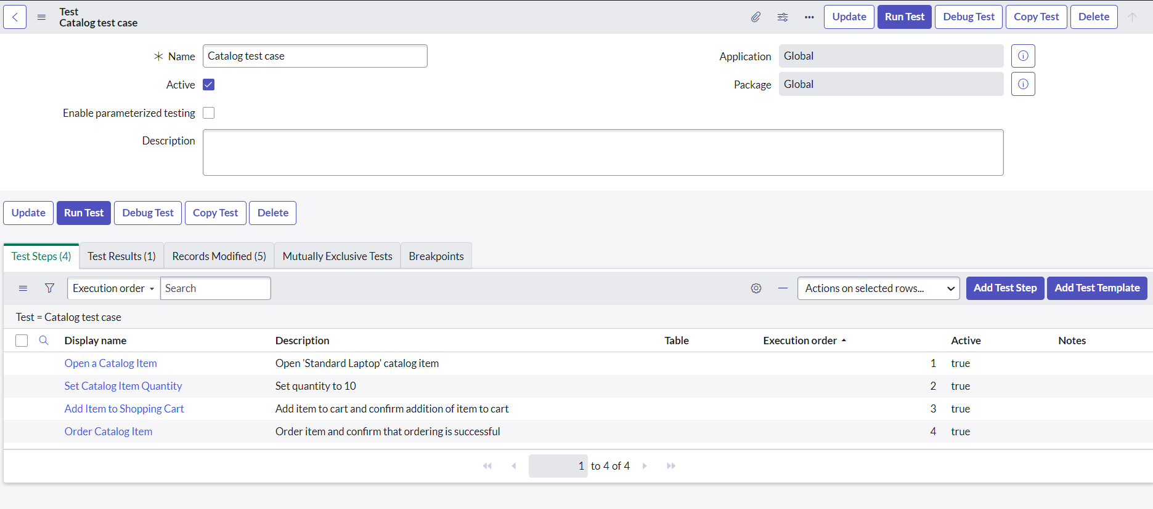

RESULT OF RUNNING THE STEPS:

